

INSTITUTE FOR ADVANCED COMPUTING AND SOFTWARE DEVELOPMENT

AKURDI, PUNE

Documentation On

**“Digital Health-ID Management System”** PG-DAC SEPT 2021

*Submitted By:*

**Group No: 55**

**PANKAJ KAKDE– 084**

**GAURAV KULKARNI- 092**

**Mr. Prashant Karhale**

**Mr. Kashinath**

**Patil**

**Centre Coordinator**

**Project Guide**

**Table of Contents**

**1. Introduction** **4**

Document Purpose 4

Problem Statement 5

Product Scope 5

Aim & Objectives 6

**2. Overall Description** **7**

Product Perspective 7

Benefits of Digital health ID Management System 8

User and Characteristics 8

Operating Environment 9

Design and Implementation Constraints 10

**3. Specific Requirements……...** **11**

External Interface Requirements 11

**4. System Diagram** **12**

Data Flow Diagram 12

Use Case Diagram 13

ER Diagram 15

**5. Table Structure** **16**

User 16

Hospitals 16

Records 16

Doctors 17

**6. Database Designs** **18**

**7. Conclusion** **19**

Future Scope 19

**8. References** **20**

**9. Screenshots** **21**

**List of Figures**

Figure 1 Data Flow Diagram 12

Figure 2 Use Case Diagram 13

Figure 3 ER Diagram 15

**1. Introduction**

Digital Health ID Management System is a web based Record Holding service, This System supports the User Friendly availability of these services to the Hospitals and to the Patient/User. The system is being used for day to day Records such as keeping every health checkups done by the patient in various Hospitals. It is programmed using Java technologies. It can be customized to fit your requirement and can either be used as a complete system or as separate modules.

* The project *Digital Health ID Management System* includes registration of patients and storing their details into the system.
* The software has the facility to generate a unique id for every patient and store the details of every patient automatically.
* It includes a search facility to know the current status of each patient. User can search the details of a particular patient using the unique id or the name of the patient. The interface is very user-friendly.
* Health ID Management System is powerful, flexible, and easy to use and is designed and developed to deliver real conceivable benefits to hospitals as well as the patients.
* It is an integrated end-to-end Health ID Management System that provides relevant information across the hospital to support effective decision making for patient care and hospital administration in a seamless flow.

Managing the key processes efficiently is critical to the success of the our management system that helps to manage the processes

**Document Purpose:**

The system will be used for providing day to day records of a patient for future clinic visits. Actually it is not easy to do this process manually because it would become very hectic. Hence it is recommended to automate the process by developing the relevant software as the world is moving from manual working to information and technology era where computerization becomes important in all part of life.



**Problem Statement:**

Existing system for a Health Management is based on our traditional way keeping records and details on paper and registers. Access of these details and papers are not granted to common member in absence of the authority. It is hard to manage all the details with pen and paper. It gets really hard to maintain the records and then keep track of past records. Hence this system is proposed to overcome the flaws of the existing system and giving power to the respective user of that record so that he/she will be able to manage the health record details easily.

**Product Scope:**

This project traverses a lot of areas ranging from business concept to computing field, and required to perform several researches to be able to achieve the project objectives. The area covers include:

* The use of the system for better services and fast processing.
* In our general health management systems we use a lot of papers that are unwanted so to decrease this unwanted use of paper we need this system.
* J2EE Technology used for the development of the application.
* Web-platform means that the system will be available for access 24/7 except when there is a temporary server issue which is expected to be minimal.
* With the help of this management system we are able to provide a digital id card for the user through which he/she can keep track of all the previous records of patient’s information, diagnosis details, previous checkups history, etc.
* Each user will get a unique id for a care free digital solution instead of carrying huge amounts of files every time a health checkup is required.
* All the hassle of managing each and every record is done manually by the receptionist and other operational staff and lot of papers are needed to be handled and taken care of. This problem can also be solved by our management system.

**Aims & Objectives:**

Specific goals are: -

* The main objective of the Digital Health ID Management System is to digitize the Front Office Management of Hospital to develop software which is user friendly simple, fast and cost-effective.
* To build an application program to reduce the unwanted use of paper.

**2. Overall Description**

**Product Perspective:**

**Existing system function:**

The existing is automated only to a particular extent they does lot of manual work. The existing system involves several processes like,

* Storing All the Data in a separate file.
* The Patient has to visit every other hospital if somehow he lost some documents.
* There is no optimal option for storing such details. So by Using Our System we can save a lot of time, money and hassle.
* The details of the every time you visited the hospitals are maintained manually.

**PROPOSED SYSTEM**

The proposed system eliminates manual work that is done. The following are the facilities that are added to an existing system in order to make more efficient:

* Maintaining the details of the Patient in the database.
* Provides Hassle free records to the respective retriever.
* The User can save any health related documents.
* User can get the information about their previous visits to the respective Hospitals.
* There is no worry of losing any important documents as they are stored in database.

**Benefits of Digital Health ID Management System :**

* This application is fully functional and flexible.
* It is very easy to use.
* This System helps the User to store details very easily and without any hassle.
* It saves a lot of time, money and Paper.
* Using software solutions for Health Id management gives the complete visibility over their previous visits to the hospitals.
* This application is available at customer service.
* It increases the efficiency of the management at offering quality services to the customers.

**Users and Characteristics:**

**Admin**:

* Admin can login to the system.
* View the list of all users.
* Add new hospital partner.
* Delete user.
* View the list of all Hospitals.

**User/Patient:**

* User can login to the system.
* View his/her details.
* Update his detail.
* Update their personal credentials.
* Delete his/her account.

**Doctor:**

* Doctor can view status such as operation history, admit history

**Hospital:**

* A Hospital can manage Doctor’s profiles.
* A Hospital can add new Doctor’s.

**Operating Environment:**

**Server Side:**

**Processor:** Intel® Xeon® processor 3500 series

**HDD:** Minimum 500GB Disk Space

**RAM:** Minimum 4GB

**OS:** Windows 8.1

**Database:** MySQL

**Client Side (minimum requirement):**

**Processor:** Intel Dual Core

**HDD:** Minimum 80GB Disk Space

**RAM:** Minimum 4GB

**OS:** Windows7



**Design and Implementation Constraints:**

* This web application developed using J2SE, J2EE, Spring MVC, MySQL and Hibernate as ORM tool and React for user interface.
* HTTP and FTP protocols are used as communication protocols. FTP is used to upload the web application in live domain and the client can access it via HTTP protocol.
* Several types of validations make this web application a secured one and SQL Injections can also be prevented.
* Since Digital Health ID Management System is a web-based application, internet connection must be established.
* The Digital Health ID Management System will be used on PCs and will function via internet or intranet in any web browser.

**3. Specific Requirement**

**External Interface Requirements:**

**User Interfaces:**

* All the users will see the same page when they enter in this website. This page asks the users a username and a password.
* After being authenticated by correct username and password, user will be redirect to their corresponding profile where they can do various activities.
* The user interface will be simple and consistence, using terminology commonly understood by intended users of the system. The system will have simple interface, compatible with standard interface, to eliminate need for user training of infrequent users.

**Hardware Interfaces:**

* No extra hardware interfaces are needed.
* The system will use the standard hardware and data communication resources.
* This includes, but not limited to, general network connection at the server/hosting site, network server and network management tools.

**Application Interfaces:**

**OS:** Windows 7

**Web Browser:**

The system is a web-based application; clients need a modern web browser such as Mozilla Firebox, Internet Explorer, Opera, and Chrome. The computer must have an Internet connection in order to be able to access the system.

**Communication Interfaces:**

* This system uses communication resources which includes but not limited to, HTTP protocol for communication with the web browser and web server and TCP/IP network protocol with HTTP protocol.
* This application will communicate with the database that holds all the patient’s information. Users can contact with server side through HTTP protocol by means of a function that is called HTTP Service. This function allows the application to use the data retrieved by server to fulfil the request fired by the user.

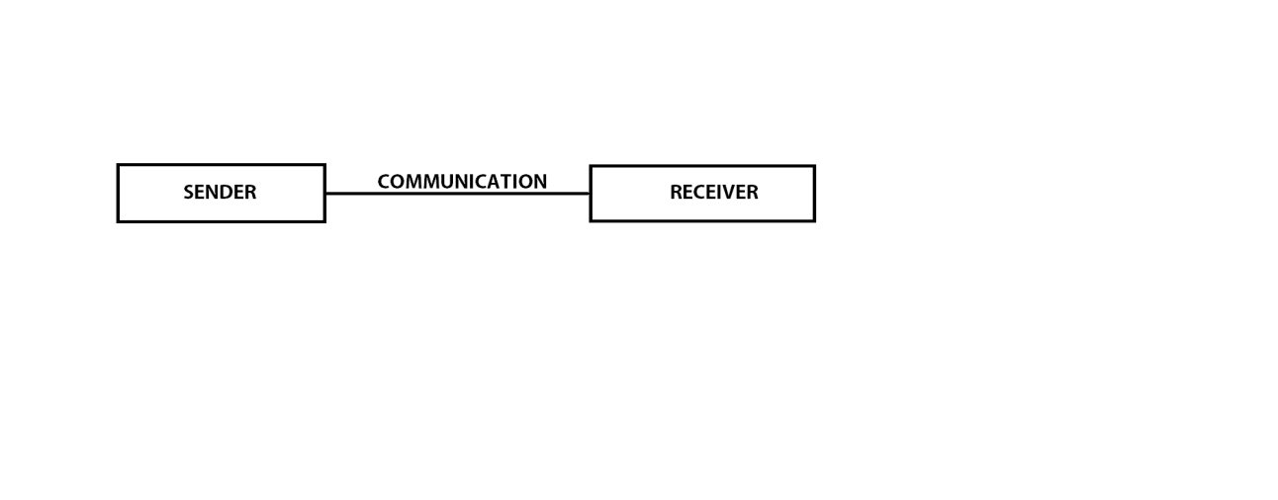

**Figure 1: Data Flow Diagram**



**4. System Diagram**

**Use Case:**

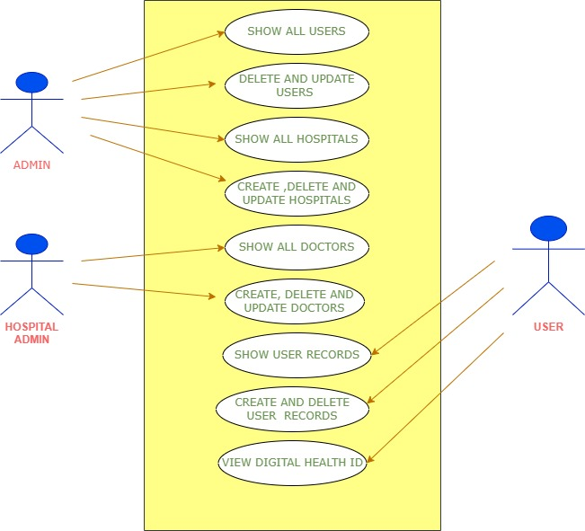

**Figure 2: Use case Diagram**

**ER Diagram:**

The Entity-Relationship (ER) model was originally proposed by Peter in 1976 [Chen76] as a way to unify the network and relational database views. Simply stated the ER model is a conceptual data model that views the real world as entities and relationships. A basic component of the model is the Entity-Relationship diagram which is used to visually represent data objects. Since Chen wrote his paper the model has been extended and today it is commonly used for database design for the database designer, the utility of the ER model is:

• It maps well to the relational model. The constructs used in the ER model can easily be transformed into relational tables.

• It is simple and easy to understand with a minimum of training. Therefore, the model can be used by the database designer to communicate the design to the end user.

• In addition, the model can be used as a design plan by the database developer to implement a data model in specific database

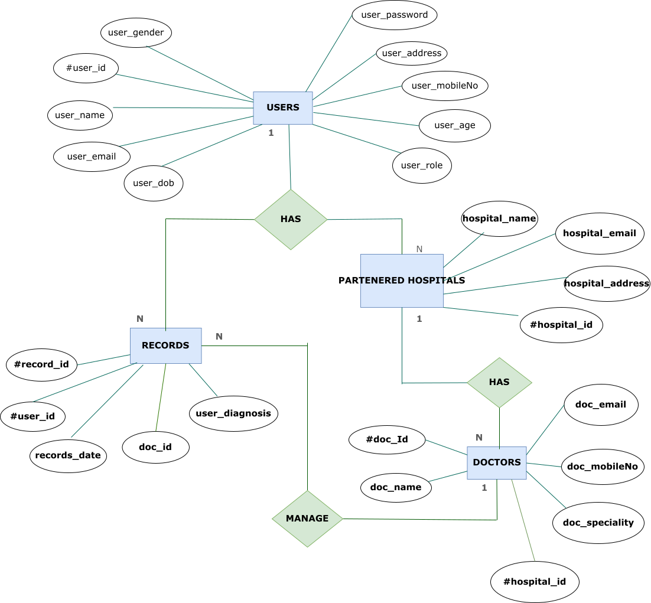

**Figure 3: ER Diagram**

**5. Table Structure**

**User:**

|  |  |  |  |  |  |
| --- | --- | --- | --- | --- | --- |
| **Field** | **Type** | **Null** | **Key** | **Default** | **Extra** |
| id | int | NO | PRI | NULL | auto_increment |
| address | Varchar(50) | YES |  | NULL |  |
| age | int | NO |  | NULL |  |
| dob | date | YES |  | NULL |  |
| email | varchar(20) | YES | UNI | NULL |  |
| gender | varchar(10) | YES |  | NULL |  |
| Mobile_no | bigint | YES | UNI | NULL |  |
| name | varchar(20) | YES |  | NULL |  |
| password | varchar(20) | NO |  | NULL |  |
| role | varchar(15) | YES |  | NULL |  |

**Hospitals:**

|  |  |  |  |  |  |
| --- | --- | --- | --- | --- | --- |
| **Field** | **Type** | **Null** | **Key** | **Default** | **Extra** |
| id | int | NO | PRI | NULL | auto_increment |
| hp_address | varchar(50) | YES |  | NULL |  |
| hp_email | varchar(20) | YES | UNI | NULL |  |
| hp_name | varchar(40) | YES |  | NULL |  |

**Records:**

|  |  |  |  |  |  |
| --- | --- | --- | --- | --- | --- |
| **Field** | **Type** | **Null** | **Key** | **Default** | **Extra** |
| id | int | NO | PRI | NULL | auto_increment |
| record_date | date | YES |  | NULL |  |
| user_diagnosis | varchar(255) | YES |  | NULL |  |
| doc_id | int | NO | MUL | NULL |  |
| user_id | int | NO | MUL | NULL |  |



**Doctors:**

|  |  |  |  |  |  |
| --- | --- | --- | --- | --- | --- |
| **Field** | **Type** | **Null** | **Key** | **Default** | **Extra** |
| id | int | NO | PRI | NULL | auto_increment |
| email | varchar(20) | YES | UNI | NULL |  |
| mobile_no | bigint | YES | UNI | NULL |  |
| name | varchar(20) | YES |  | NULL |  |
| speciality | varchar(15) | YES |  | NULL |  |
| hospital_id | int | NO | MUL | NULL |  |

**6. Database Design**

The data in the system has to be stored and retrieved from database.

Designing the database is part of system design. Data elements and data structures to be stored have been identified at analysis stage.

They are structured and put together to design the data storage and retrieval system.

A database is a collection of interrelated data stored with minimum redundancy to serve many users quickly and efficiently.

The general objective is to make database access easy, quick, inexpensive and flexible for the user.

Relationships are established between the data items and unnecessary data items are removed.

Normalization is done to get an internal consistency of data and to have minimum redundancy and maximum stability.

This ensures minimizing data storage required, minimizing chances of data inconsistencies and optimizing for updates. The MS Access database has been chosen for developing the relevant database.

**7. Conclusion**

This system is a user friendly and GUI based website. It satisfies all the requirements of the proposed system to a great extent. This system is developed in a way that it is easy to use and easy to maintain. This system is mainly designed to reduce the cost, to increase the experience of the customer and to increase the operational efficiency. The system is developed to help the customer to find the location of the package. It helps them to know the package departure status. This added feature makes the user to conveniently use the system.

**Future Scope**

This project can be enhanced further by adding live tracking to it. The software is flexible enough to be modified and implemented as per future requirements. We have tried our best to present this free and user–friendly website to the customers.

* Adding more modules/functionalities to the current project such as a Doctor module , a Nurse module, a Pharmacist module , Laboratories module, etc.
* We can also add a billing system which is attached to the unique health id of the user by which he/she can also keep track of the different bills required in a seamless and efficient manner.
* We can keep information about various diseases and medicines available to cure them.



* 1. **References**

1. Ayushman Bharat Health Account (Previously Health ID) – By Indian Government.

**ONLINE REFERENCE**

1. Learning spring boot, angular and MySQL to create responsive website.
2. Javatpoint website for core java concepts.
3. Tutorials point website for learning MySQL.

**8. Screenshots**

**HOMEPAGE:**

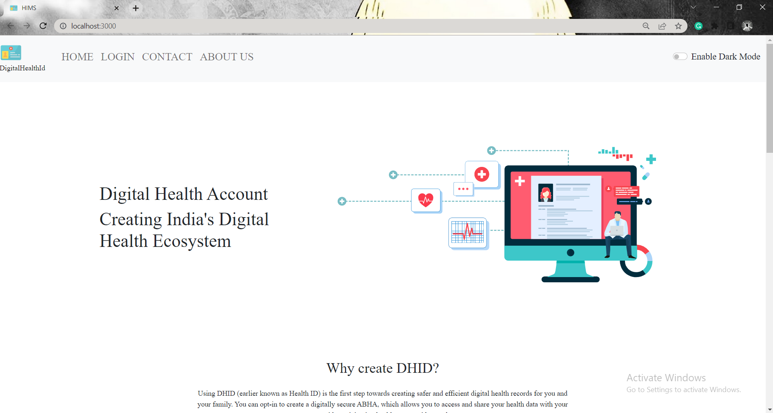

**HOMEPAGE AFTER DARK MODE ACTIVATION:**

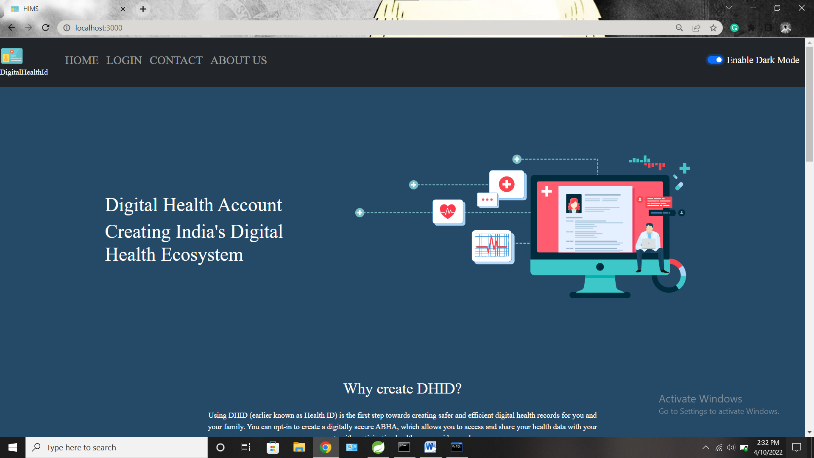

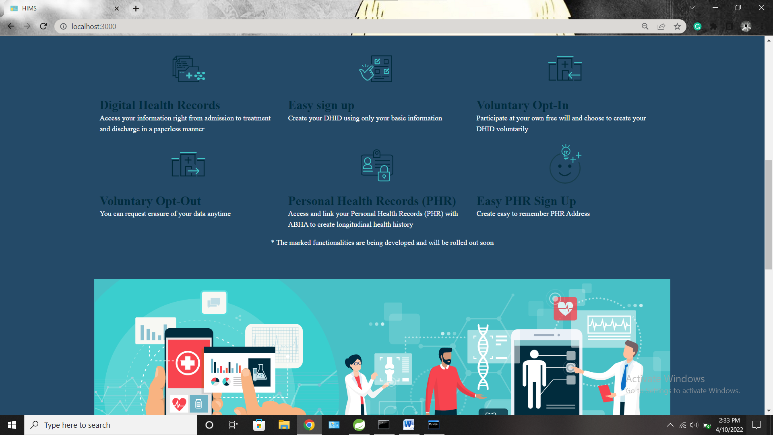

**LOGIN PAGE :**

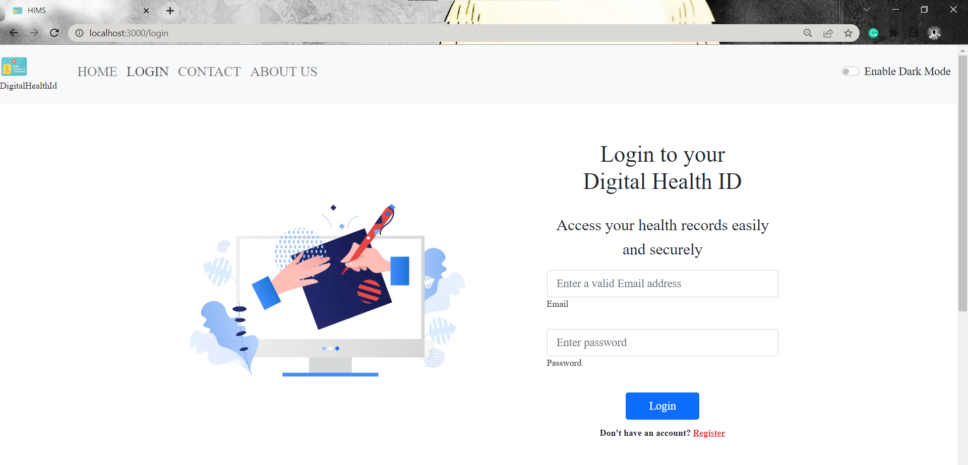

**ADMIN LOGGED IN:**

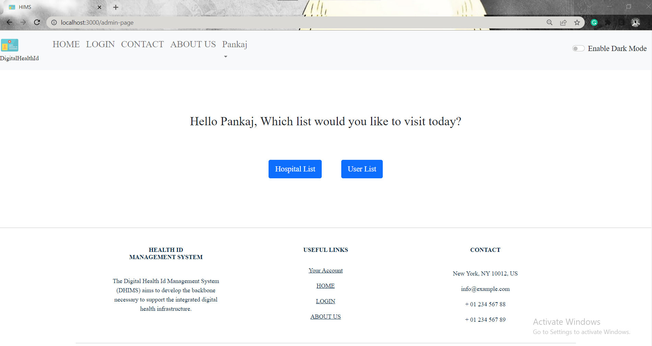

**HOSPITAL LIST:**

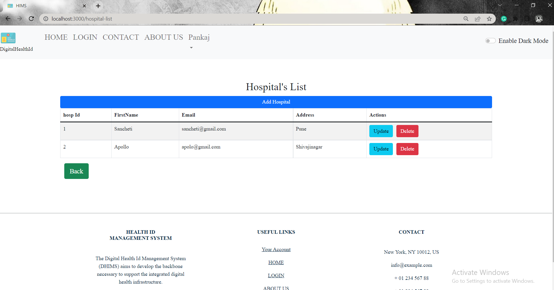

**USER LIST:**

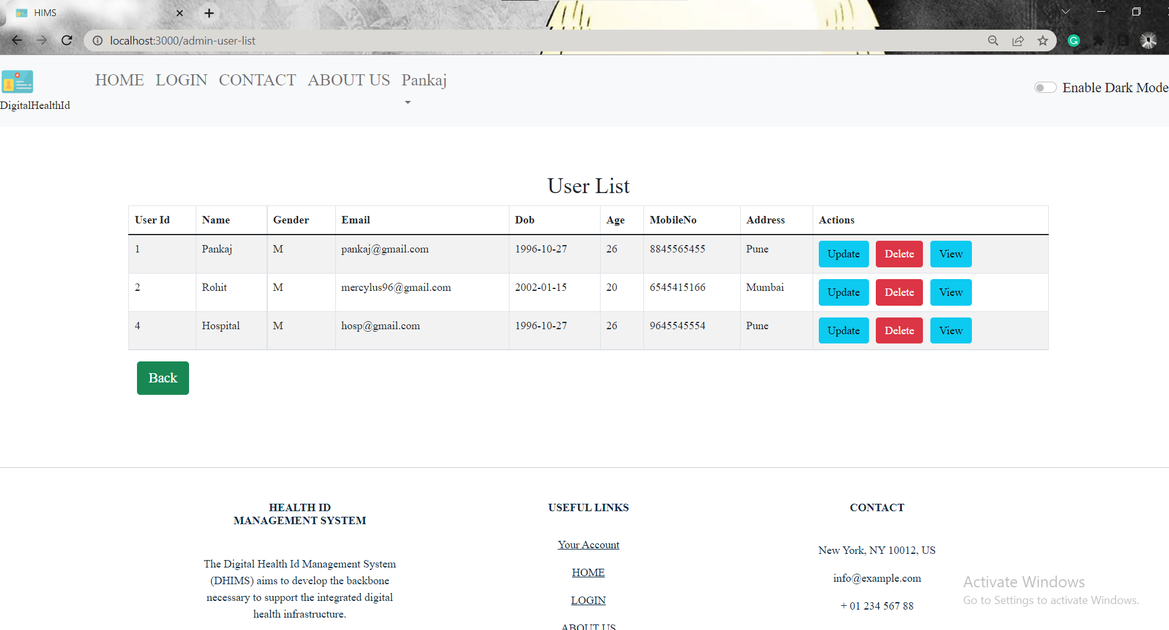

**AFTER CLICKING REGISTER ON HOME PAGE :**

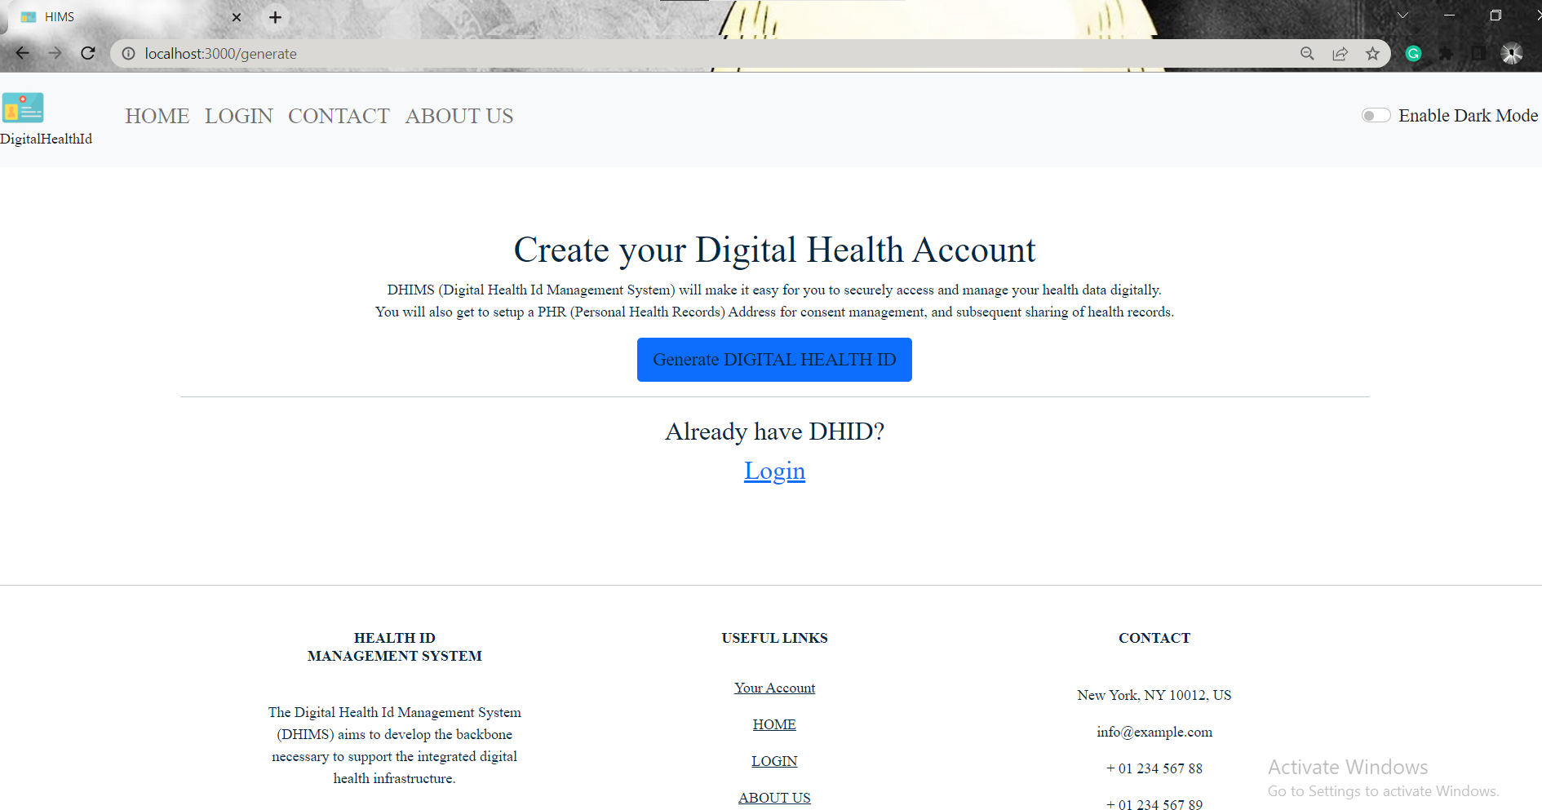

**FORM FOR USER SIGN-UP:**

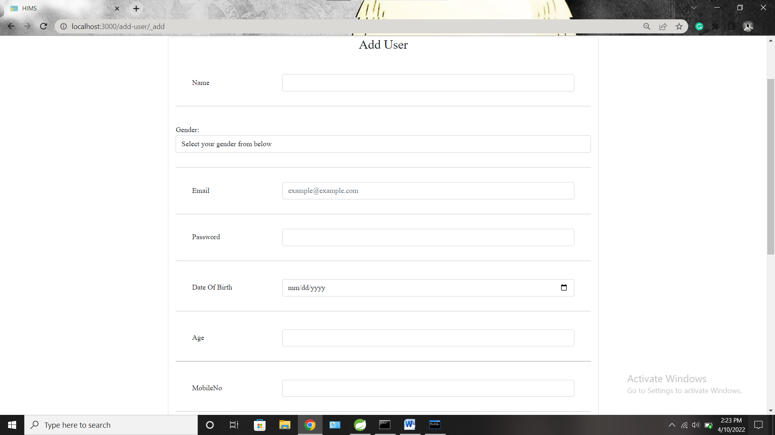

**DOCTOR LIST (ADMIN):**

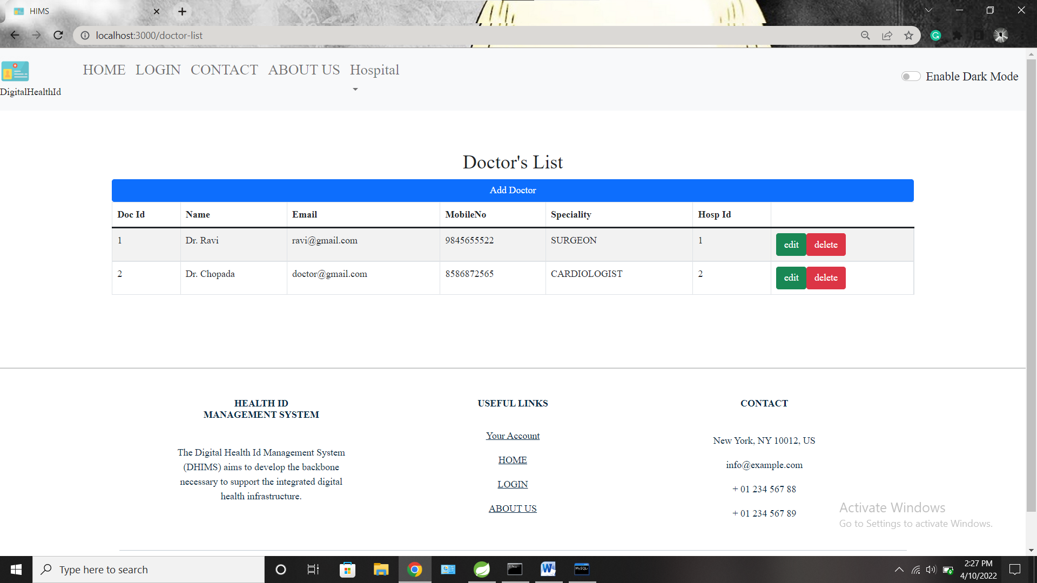

**USER LOGIN:**

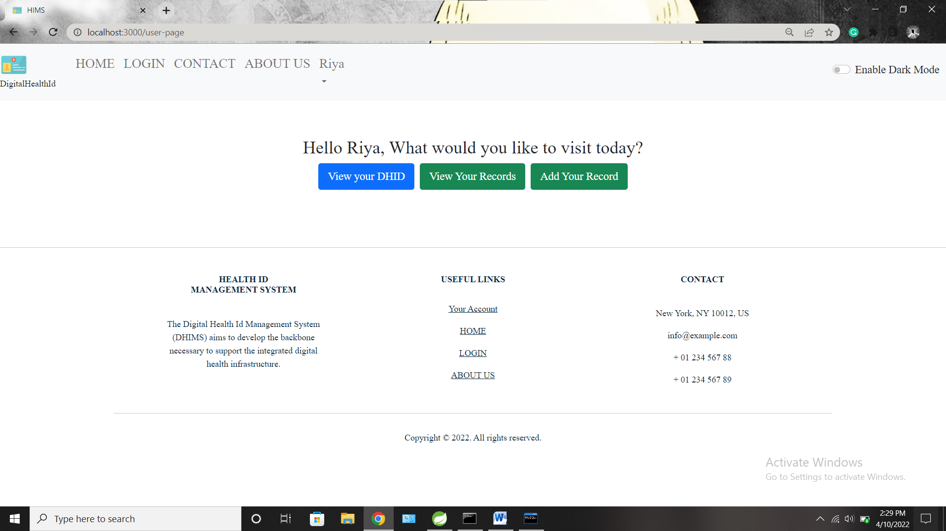

**HEALTH ID CARD :**

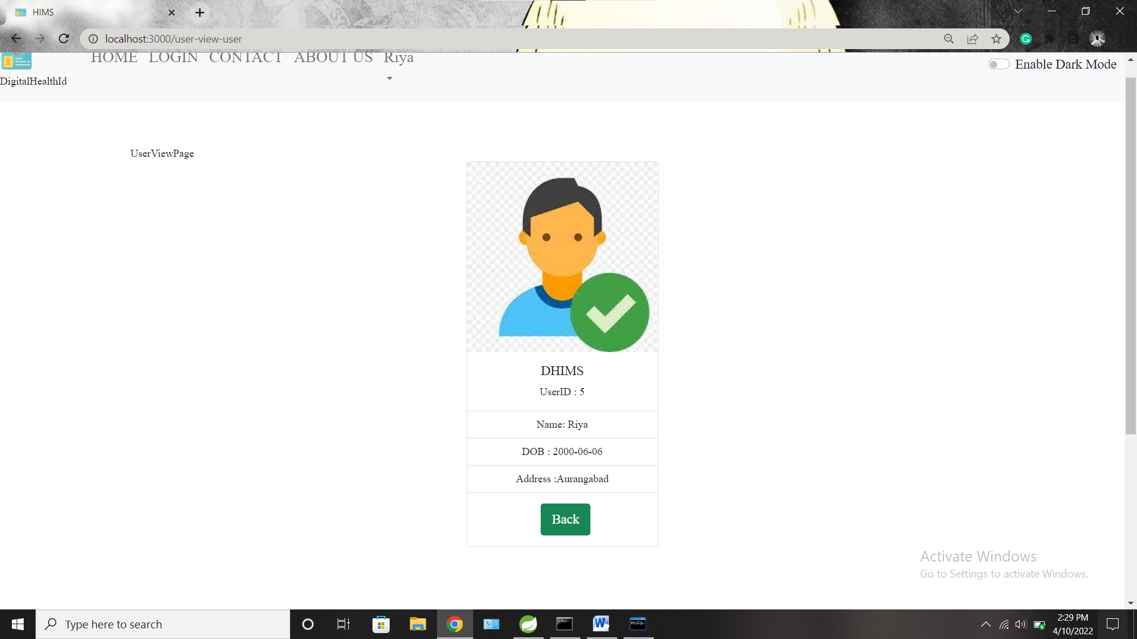

**AFTER CLICKING ADD RECORDS:**

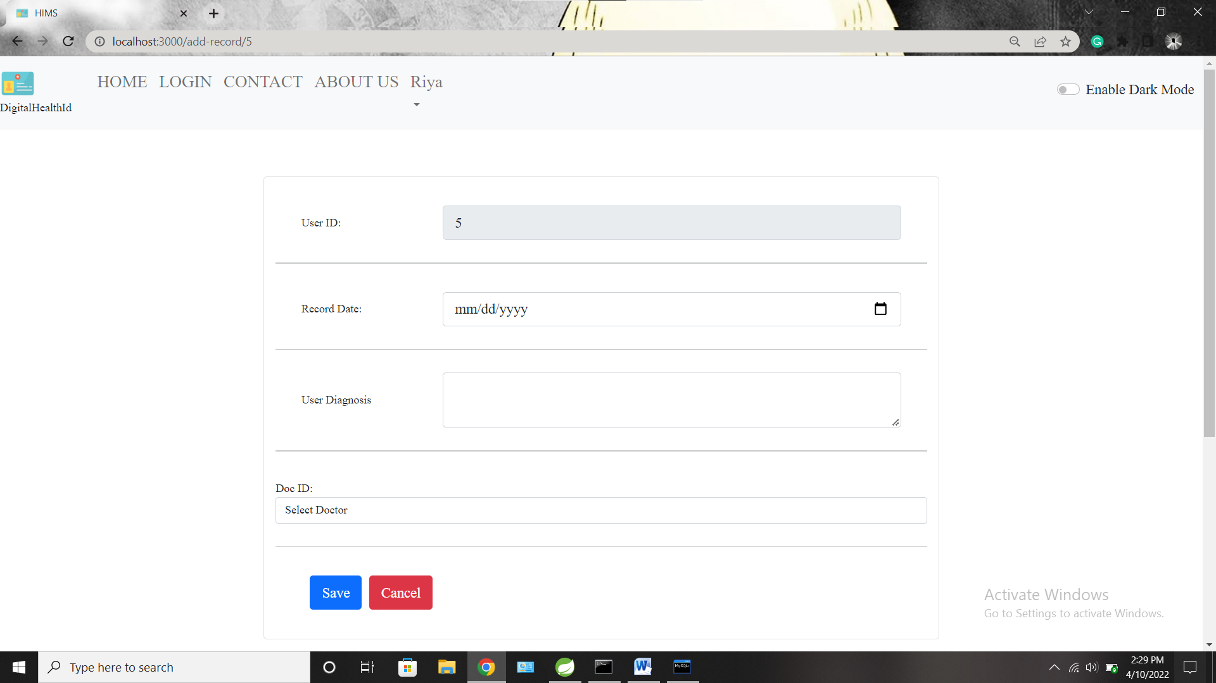

**AFTER CLICKING VIEW RECORDS:**

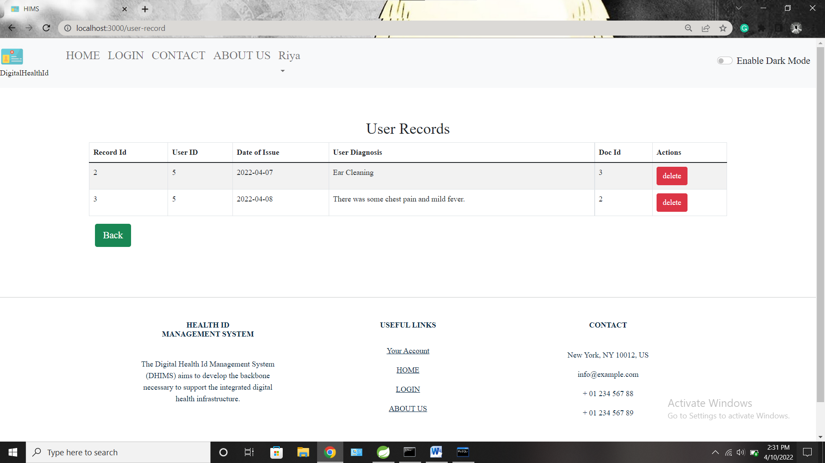

**ADMIN CONTACT:**

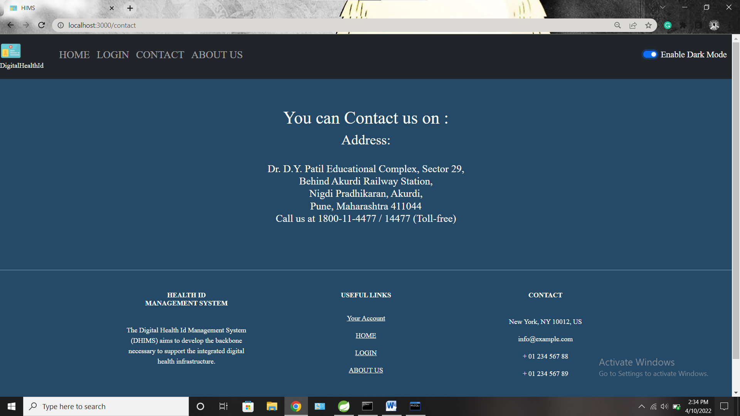

**ABOUT APPLICATION:**

